**Basic Operation**

The basic operation of ignition system is described in this video:

<https://www.youtube.com/watch?v=OMLSNwQiiKg>

**Points-Style**

The basic architecture for ignition systems is best illustrated in the original points-style ignition (as described in the video linked above).

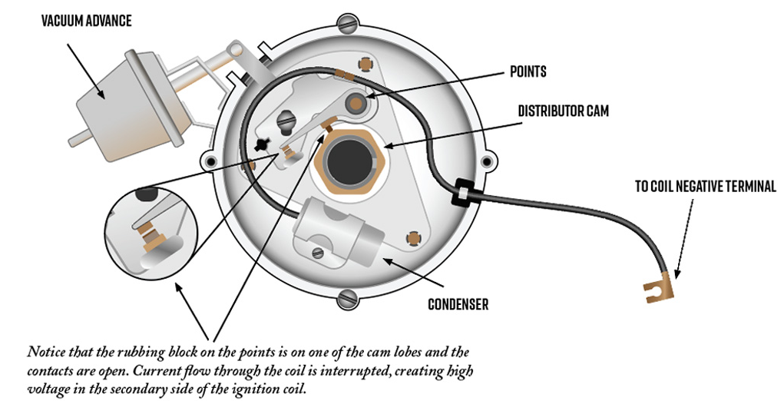

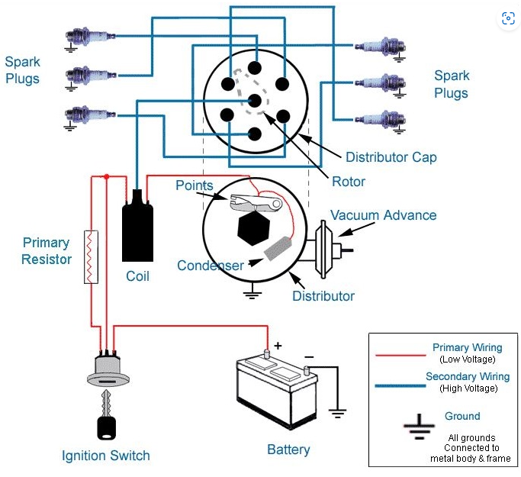

Typically, the only wires to the distributor are +12V from the coil and ground.

**Electronic Ignition**

Electronic ignition systems function analogously as the points-style but with key mechanical components replaced with electronic ones. Specifically, the points and condenser are replaced with solid-state components. At IIS, three types of electronic distributors are used.

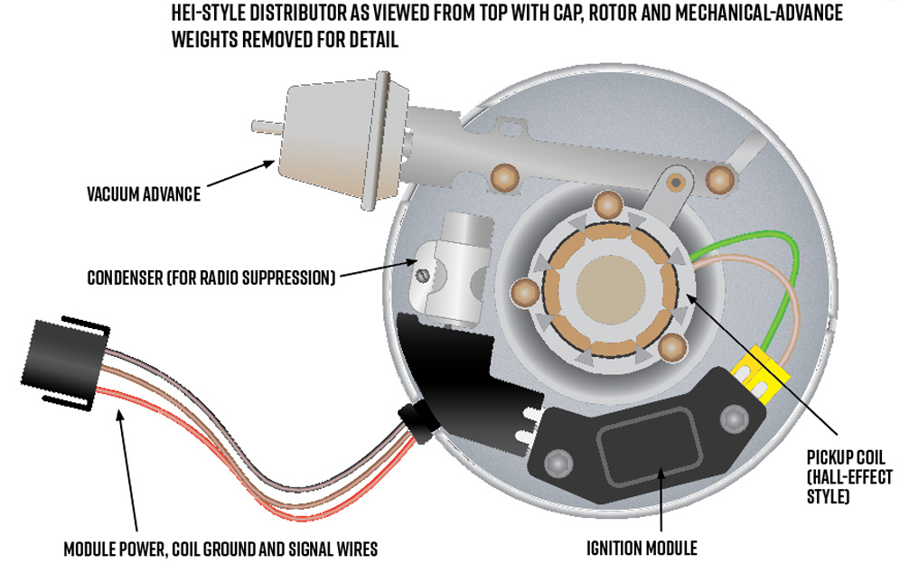

1. HEI (High Energy Ignition) –
   1. IIS uses the HEI variation featuring an integrated coil (on the cap) and vacuum advance.
   2. Used primarily on engines equipped with mechanical fuel systems.
   3. Vacuum advance remains capped.
   4. The connector on the cap has two connections: one labeled “+”, the other “tach”.
   5. Only requires +12V power to operate.
   6. The tachometer signal must be conditioned and clamped by the receiving device.

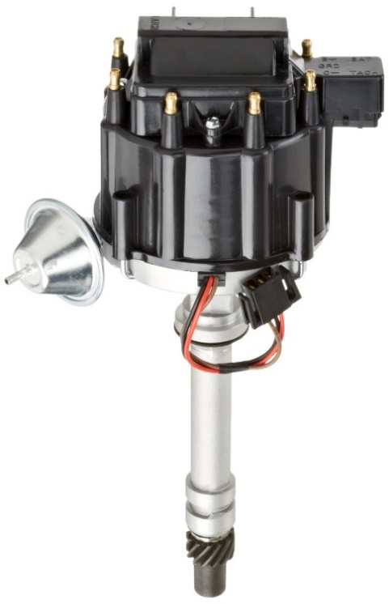

1. EST (Electronic Spark Timing) –
   1. A type of HEI that uses an electronic control module to control timing rather than vacuum or centrifugal mechanisms.
   2. This distributor features a speed (tachometer) output which allows the “smart” governor (L-Series) to be used without a separate ECM.
   3. It is the most common distributor used at IIS.
   4. It requires an external coil.
   5. The most notable feature about its appearance is the two connectors.

The following illustration shows typical wiring to EST distributor; but wiring to the 4-position connector varies per application.

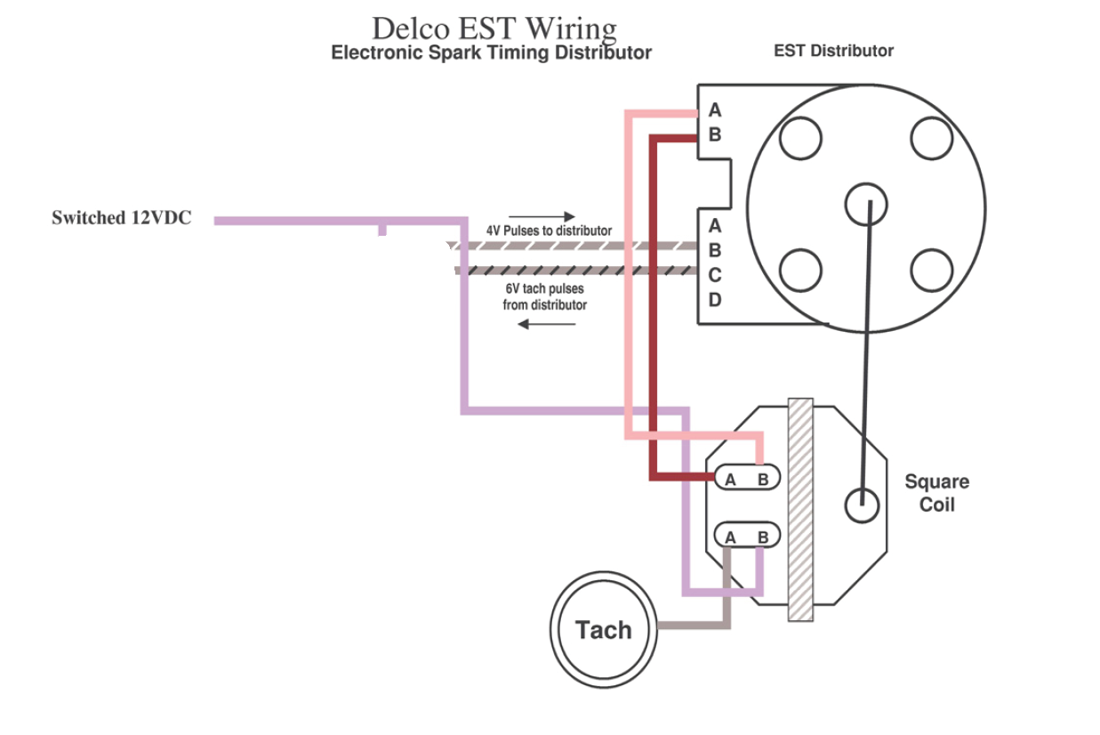

Referring to the 4-position connector in the illustration above:

* **Pin B** receives the “override (cranking) signal”  which “is zero volts during cranking (less than 400 rpm or 5 to 15 seconds), then there is 5 volts on this wire after the engine starts to signal the *8*-pin module that it should use” the external signal (if provided) to control timing.
* **Pin D** is used to receive this external timing control if an ECM is utilized for spark control.
* “The module converts the AC signal from the variable reluctor pick-up in the distributor to a 'square wave' tach signal “. This signal is transmitted on **Pin C**.
* **Pin A** is a transducer ground circuit.

This web page offers detailed technical information about HEI (and EST) modules:

[General Motors HEI Ignition Control (megamanual.com)](https://www.megamanual.com/ms2/GM_7pinHEI.htm)

Here are a couple of useful videos further explaining EST distributors:

[EST Shop Manual](https://www.google.com/url?sa=t&rct=j&q=&esrc=s&source=web&cd=&ved=2ahUKEwikv4eXzYH_AhX3ADQIHWN4DB4QFnoECBsQAQ&url=https%3A%2F%2Ff01.justanswer.com%2Foldnewenglandmarine%2Fdeacd8eb-a4ca-4db4-9bec-6e9bb71197e7_Delco_EST.pdf&usg=AOvVaw1-J68KYCDLjkFf-Koq9V0H)

[Marine Delco EST Distributor - YouTube](https://www.youtube.com/watch?v=yU1S1WKFMP0)

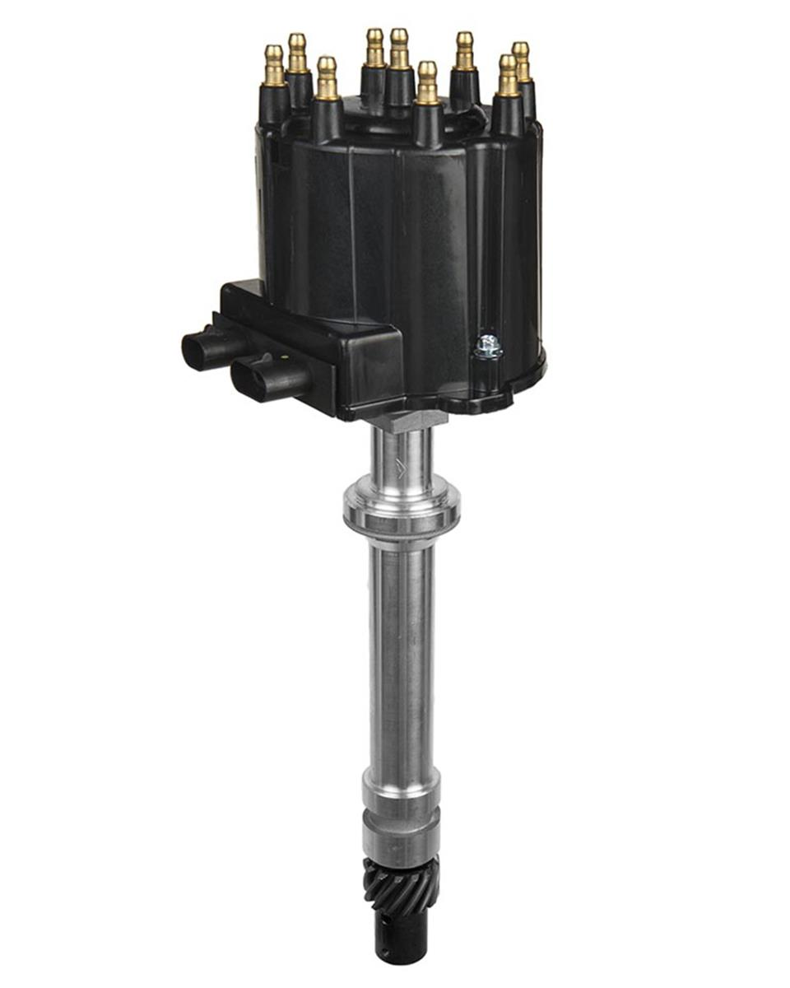

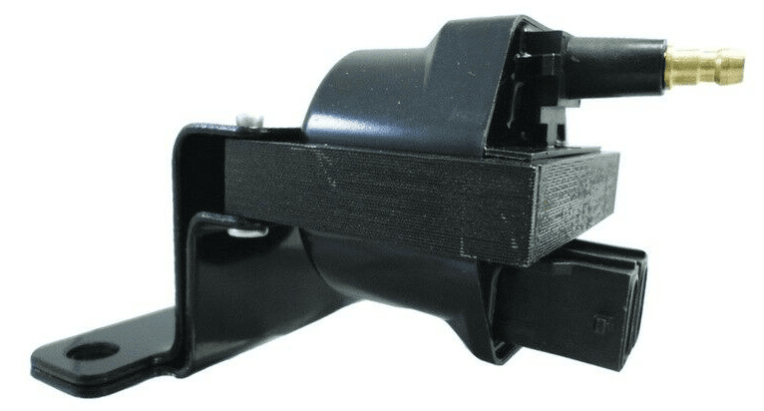

1. HVS (High Voltage Switch, a.k.a. Flat Top) –
   1. This is an HEI distributor that is characterized by the low-profile, horizontal spark plug wire terminals.
   2. Utilizes a 3-position connector.
   3. Requires ignition coil with integrated control module.

